IAM Monitoring Module Implementation Documentation

Step 1: Create an AWS Account.

Step 2: Create a test IAM User in AWS for monitoring purpose and assign policies such as SecurityAudit. Also, add a policy which gives suspiciously excess permissions such as IAMFullAccess. This is done to simulate a condition where our program is triggered.

Step 3: Install AWS CLI for Windows and configure credentials such as AWS Access Key, Secret Access Key, and default region and output format.
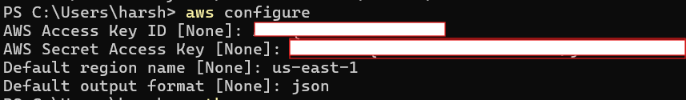

Step 4: Install Python and boto3 (AWS SDK for Python).
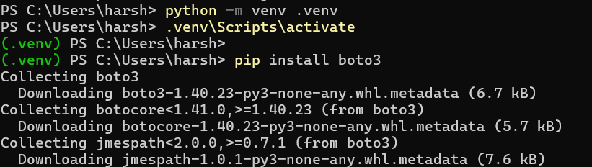
Step 5: Create a file named iam_monitor.py and write the following code:
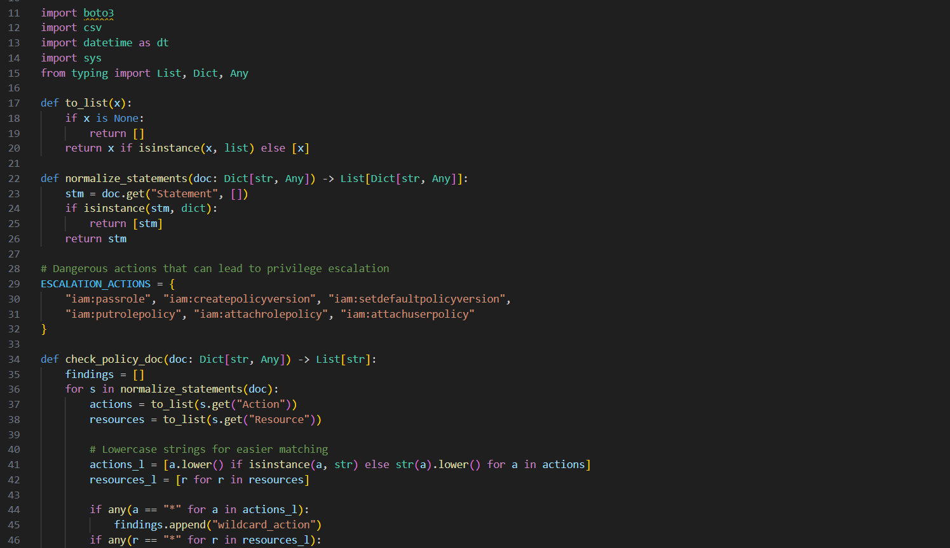
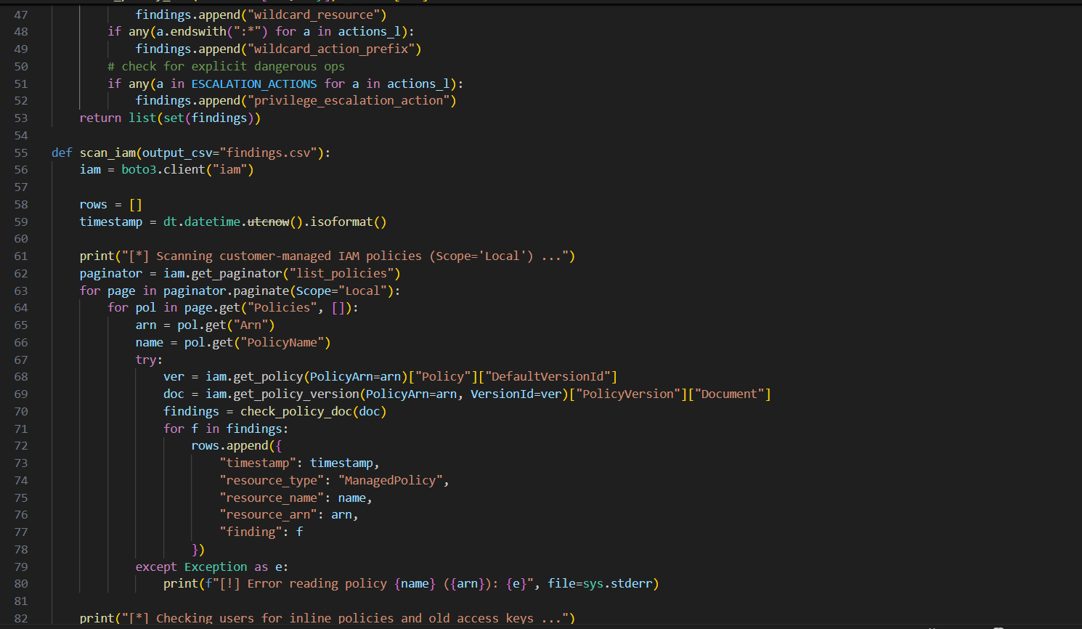
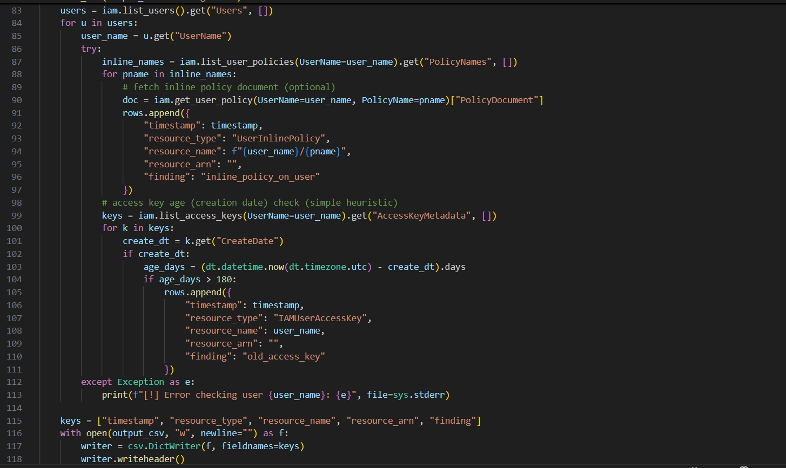
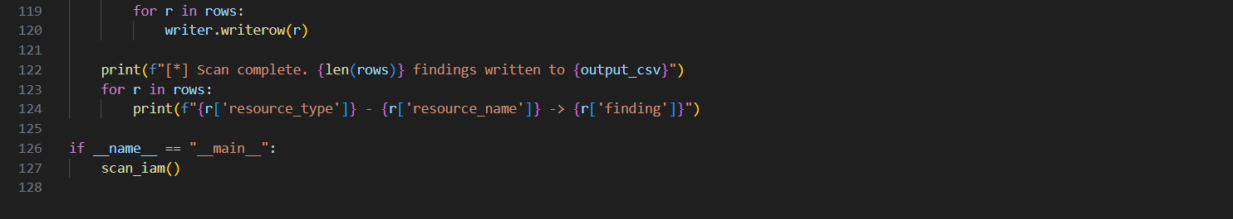

Step 6: Use AWS CLI to create a customer-managed policy with wildcards so the script flags as possible IAM least privilege violation.
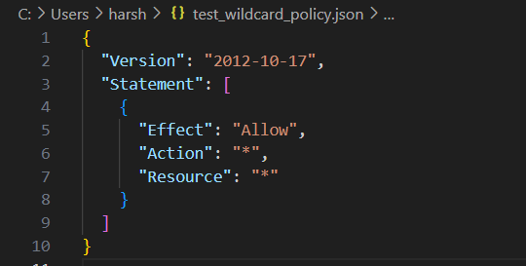

Step 7: This command creates a dangerously permissive IAM policy named TestWildcardPolicy, so that your monitoring tool has something to detect and report.
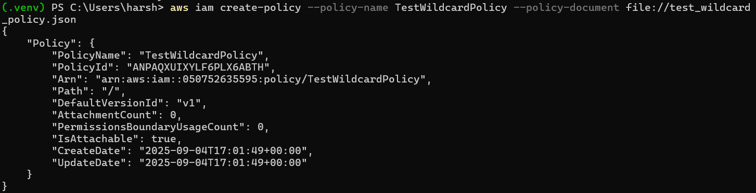

Step 8: Run the script and it will flag for bad policies write its findings to findings.csv
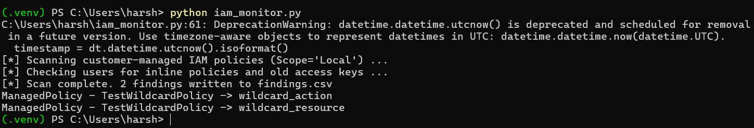
- ManagedPolicy - TestWildcardPolicy -> wildcard_action
→ Your script detected that the policy allows Action: "*" (all actions).
- ManagedPolicy - TestWildcardPolicy -> wildcard_resource
→ It also flagged that the policy applies to Resource: "*", meaning it grants access to any resource.
- 2 findings written to findings.csv
→ The script stored the results in a CSV file, which you can open in Excel, Notepad, or import into dashboards (e.g. Grafana) for visualization.

Findings.csv will document the following information regarding the policy creation.
This module can be extended in future for functionalities such as:
Privilege escalation patterns (e.g., iam:PassRole, sts:AssumeRole, iam:CreatePolicyVersion).
Over-permissive S3 bucket policies (public Principal: "*") → check via s3.get_bucket_policy.
Unused IAM users/roles → flag accounts with no login or API activity for X days.
MFA enforcement → detect IAM users without MFA enabled.
Inactive access keys → disable or flag keys unused for > 90 days.
Root account usage → alert if root account used (best practice: avoid).

